**Audit Mode: Windows 10 - Step by Step Guide**

December 21, 2017

In this article we will show you how to create a  **prepare a highly customized, personal Windows 10 install image**. Before starting the installation, we need to make sure that our computer or virtual machine is not connected to network, because Windows 10 sysprep process will later fail if the PC was connected to Internet during the installation.

Using the Sysprep utility simplifies the installation and configuration of the operating system in a large company. Once prepared standard Windows 10 image installed and configured in the right way, the operating system (with a certain installed software, with the system settings, with the specified rights and restrictions) deployed to all computers of the company using MDT, WDS (take a look at [Deploying Windows 10 with MDT and WDS](https://theitbros.com/deploy-windows-10-on-windows-server-2012-r2/)), SCCM or manually.

**Step 1 – Boot to Windows 10 Audit Mode**

Start Windows installation normally. After reboot or two Windows is installed and process stops waiting your input. At this point we need to click on the **Use express settings** button. On next dialog you should not type a username, so don’t enter it (this stage of OS setup has a name OOBE — out-of-box experience for the end user).

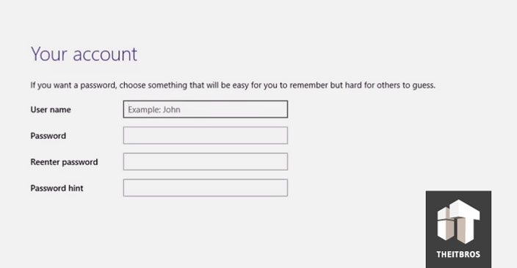

Instead, press and hold down the **CTRL+SHIFT+F3 keys combination**. OS will now reboot to a special customization mode, the **Windows 10 Audit Mode**.

As no user profiles exist yet, Windows will use its built-in administrator account to sign in to Audit Mode. There is only one visible sign to mark that you have entered the Windows 10 Audit Mode desktop, the Sysprep dialog in the middle of the display. Do not close the sysprep utility window — you will need it at the end of the configuration step. Just minimize it.

In auditSystem, the built-in administrator account is enabled by the system, and after logging into the system, the built-in administrator account is disabled during auditUser. This enables you to use audit mode with administrator privileges, but the next time the computer shuts down, the built-in administrator account will continue to be disabled. For more information, see [Enable and Disable the Built-in Administrator Account](https://docs.microsoft.com/en-us/previous-versions/windows/it-pro/windows-vista/cc766343%28v%3dws.10%29).

Until now the installation was done without a network connection. So, you can connect your PC to network and Internet now.

**Step 2 – Begin customization in Windows 10 Audit Mode**

After entering the audit mode, you can start installing, updating default all user apps applications and configuring the operating system settings. All these apps and settings would be present in the default user profile. Default profile is used as base profile when you later create users on your Windows PC.

Consider two types of applications that may be installed. Applications that are installed from executable files (e.g. setup.exe) will be referred to as Application Installations. Applications that are part of the Microsoft Store (provisioned applications) will be referred to as Microsoft Provisioned Apps.

Application Installations may be launched from Windows File Manager by browsing and launching the appropriate executable.

To install Microsoft Provisioned Apps, use PackageManagement (aka OneGet), an integrated module of PowerShell.  As some functions of the Start Menu and Search are disabled in Windows 10 Audit Mode, **Start PowerShell manually** by browsing into the Windows folder and launching it from there.

Go to **C:\Windows\syswow64\WindowsPowerShell\v1.0** and then run **powershell_ise** application.

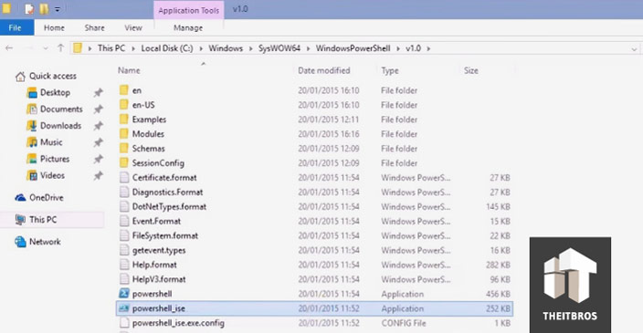

First thing to do is extend the rights to run scripts, in order to be able to install software from a package provider later on.

Use the Set-Executionpolicy Unrestricted command.

Next, a package manager or provider must be selected. The package manager requires unrestricted script execution policy, which is why it was set first thing after PowerShell is launched.

Add the provider using the Get-Packageprovider <PROVIDER> command.

More information on this command can be found here: <https://docs.microsoft.com/en-us/powershell/module/packagemanagement/get-packageprovider?view=powershell-5.1>

**Step 3 – Install the software you need**

To install Microsoft Provisioned Apps, use the Install-Package script.

For example, to install Opera, Google Chrome, VLC, Adobe Reader, 7Zip, K-Lite Codec Pack Full and Zoomit.

Find-Package -Name Opera, GoogleChrome, VLC, AdobeReader, 7Zip, Zoomit. k-litecodecpackfull | Install-Package

If the system requires a reboot to install the application or update, you can do it. After reboot, the system will return to audit mode.

**Step 4 – Installing Windows Update in Audit mode (optional)**

Starting with Windows 8.1, in the auditing mode, you cannot install updates using the Windows Update Center in Settings panel.

The Windows Update Center checks to see if the system has completed the OOBE stage (from which you are logged in). If not, the update is not performed.

To automatically update the system from the console, you can take on a very handy PowerShell module — the [PSWindowsUpdate](https://gallery.technet.microsoft.com/scriptcenter/2d191bcd-3308-4edd-9de2-88dff796b0bc) Module from TechNet.

Save the PSWindowsUpdate.zip archive to a USB drive and (this is important!) right click on it -> Properties -> Unlock.

Create file **PSWindowsUpdate.cmd** on the USB drive with one command:

PowerShell -ExecutionPolicy RemoteSigned -Command Import-Module PSWindowsUpdate; Get-WUInstall -AcceptAll -IgnoreReboot

Unpack the PSWindowsUpdate.zip to the folder: C:\Windows\System32\WindowsPowerShell\v1.0\Modules.

Run PSWindowsUpdate.cmd as administrator.

That’s all! Available updates will be downloaded and installed automatically.

When the update is complete, you can delete the module that was previously copied to the Windows folder.

**Step 5 – Uninstall built-in apps (optional)**

Also you can uninstall built-in apps, but it’s really up to you. So, if you don’t want to uninstall built-in apps, just skip this step.

Paste the following scripts onto the PowerShell command line and press Enter.

Get-AppxPackage *3dbuilder* | Remove-AppxPackage  
Get-AppxPackage *windowsalarms* | Remove-AppxPackage  
Get-AppxPackage *Appconnector* | Remove-AppxPackage  
Get-AppxPackage *windowscalculator* | Remove-AppxPackage  
Get-AppxPackage *windowscommunicationsapps* | Remove-AppxPackage  
Get-AppxPackage *windowscamera* | Remove-AppxPackage  
Get-AppxPackage *CandyCrushSaga* | Remove-AppxPackage  
Get-AppxPackage *officehub* | Remove-AppxPackage  
Get-AppxPackage *skypeapp* | Remove-AppxPackage  
Get-AppxPackage *getstarted* | Remove-AppxPackage  
Get-AppxPackage *zunemusic* | Remove-AppxPackage  
Get-AppxPackage *windowsmaps* | Remove-AppxPackage  
Get-AppxPackage *Messaging* | Remove-AppxPackage  
Get-AppxPackage *solitairecollection* | Remove-AppxPackage  
Get-AppxPackage *ConnectivityStore* | Remove-AppxPackage  
Get-AppxPackage *bingfinance* | Remove-AppxPackage  
Get-AppxPackage *zunevideo* | Remove-AppxPackage  
Get-AppxPackage *bingnews* | Remove-AppxPackage  
Get-AppxPackage *onenote* | Remove-AppxPackage  
Get-AppxPackage *people* | Remove-AppxPackage  
Get-AppxPackage *CommsPhone* | Remove-AppxPackage  
Get-AppxPackage *windowsphone* | Remove-AppxPackage  
Get-AppxPackage *photos* | Remove-AppxPackage  
Get-AppxPackage *WindowsScan* | Remove-AppxPackage  
Get-AppxPackage *bingsports* | Remove-AppxPackage  
Get-AppxPackage *windowsstore* | Remove-AppxPackage  
Get-AppxPackage *Office.Sway* | Remove-AppxPackage  
Get-AppxPackage *Twitter* | Remove-AppxPackage  
Get-AppxPackage *soundrecorder* | Remove-AppxPackage  
Get-AppxPackage *bingweather* | Remove-AppxPackage  
Get-AppxPackage *xboxapp* | Remove-AppxPackage  
Get-AppxPackage *XboxOneSmartGlass* | Remove-AppxPackage

**Step 6a – Preparing to use the UIU Plug-ins 2.0 for SCCM or MDT**

Now we need to **create an Answer File**. An answer file is a set of instructions in an XML file. When sysprep is run, it reads these instructions, what changes it should make to the Windows image.

At first we need to **create a catalog file**. For that we need the install.wim file from a Windows install disk or ISO file.

**Note**. Windows 10 Build 9926 install.wim file for some reason cannot be used for the catalog file. This will be fixed in future builds, for sure. But for now we have a workaround.

To get an answer file for our Build 9926, at first we have to create the catalog using Windows 8.1 or Windows 10 Builds 9841, 9860 or 9879 install.wim file, and later edit the answer file.

Find the **install.wim** on any install media for above mentioned Windows versions and copy to the desktop of the PC you are using for this process now.

The install.wim can be found in Sources folder in any Windows install media. We are using the install.wim from Windows 8.1 Update 1.

[**READ ALSO**  How to Manage Backups using PowerShell](https://theitbros.com/manage-backups-using-powershell/)

Open **Windows System Image Manager**.

Location of the Windows System Image Manager is:

C:\Program Files (x86)\Windows Kits\8.1\Assessment and Deployment Kit\Deployment Tools\WSIM\imgmgr.exe

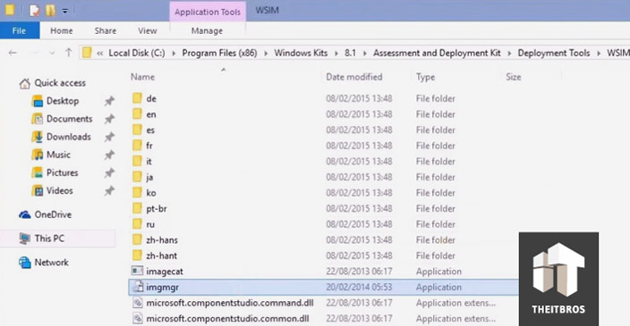

Now, create a new answer file, and select the install.wim we just copied to the desktop.

Creating the catalog will take quite a long time.

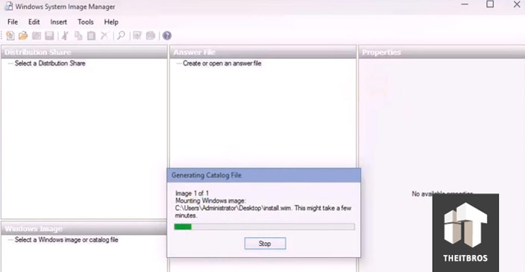

Once it is done, we need to do the most important thing, **set the CopyProfile value to TRUE**. This setting is telling Sysprep to copy all our customizations to default user profile.

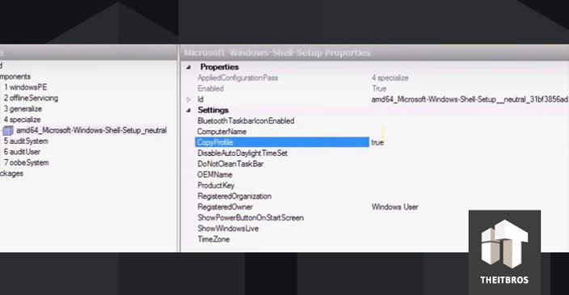

Once it is done, let the Windows SIM validate your answer file and check it for errors. Click on **Tools** -> **Validate**.

In our case it is nothing to be worried about, only warnings about some deprecated settings no longer possible to change, and notices that because we did not change some settings, they will be left out.

Now, we can save the answer file and name it as we want to. But the **file extension must always be .xml**. Save the answer file to root of any drive other than C:.

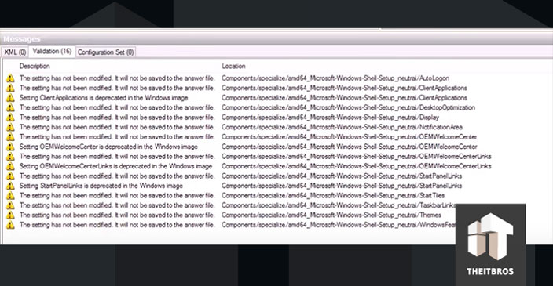

After that you can delete the install.wim and catalog files from the desktop.

Because the install.wim file that we have used is not belonging to the version of Windows we will Sysprep, the answer file must be edited. So, open it in Notepad.

**Change the path to your Windows 10 install.wim** file at the bottom of the answer file. In our case we need to change drive and Windows version to Windows 10 Pro. Now, save this file as **CustomImage.xml**on the drive D:.

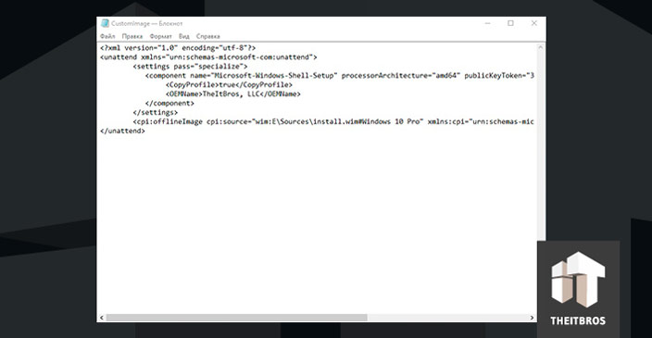

Finally let’s run sysprep. Open up Command Prompt as admin.

Go to Sysprep folder and type in the following command:

Sysprep.exe /generalize /oobe /shutdown /unattend:D:\CustomImage.xml

In our case the answer file is on the root of the drive D:. Change the command according to where your answer file is located.

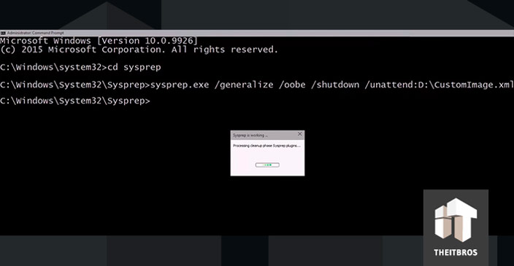

**Step 6b – Using the UIU Classic v4.x**

Launch the UIU Classic Product and if you are familiar with the process, follow your typical process of configuring and running the UIU. If you are new to the product, please familiarize yourself with the user guide before attempting to use the UIU: <https://www.bigbangllc.com/User-Guides/UIU-Classic-User-Guide>

Sysprep will apply your answer file and shutdown the computer. Now this image is ready to be imaged using your choice of imaging software.

When the computer has booted to imaging and recovery tool, **create a system image** according to instructions for the program you are using. Once it is done, shutdown the computer.

You have created a generalized, highly customized Windows install image which can be restored to any computer. Restoring takes only half of the time needed for installation.

**Step 7 – Using the UIU Classic v4.x**

Once a machine is imaged using the UIU image created above, start the PC normally to finalize the installation.

The Welcome phase first boot is a bit different in a Sysprepped Windows. You will be asked to enter the product key. This is of course not necessary, you can skip it.

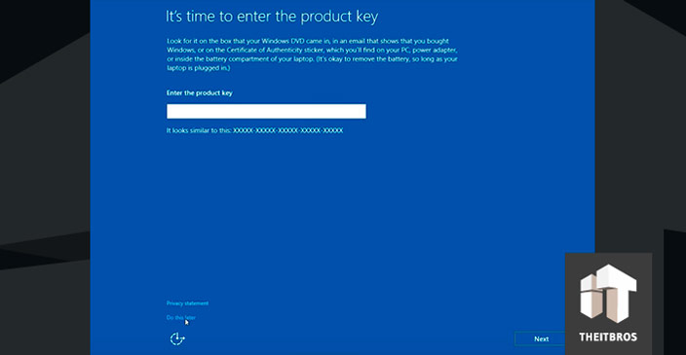

Now, create a local account. You can later change it to a Microsoft Account.

Finally, we did it. After installation you will see that all customizations are there, all software you installed in Audit Mode are there as well.